[Customer segmentation](https://searchcustomerexperience.techtarget.com/tip/9-strategies-for-email-marketing-segmentation) is the practice of dividing a customer base into groups of individuals that are similar in specific ways relevant to marketing, such as age, gender, interests and spending habits.

Customer segmentation, also called consumer segmentation or client segmentation, procedures include:

* Deciding what [data](https://searchdatamanagement.techtarget.com/definition/data) will be collected and how it will be gathered
* Collecting data and integrating data from various sources
* Developing methods of [data analysis](https://searchsqlserver.techtarget.com/definition/data-mining) for segmentation
* Establishing effective communication among relevant business units (such as marketing and customer service) about the segmentation
* Implementing applications to effectively deal with the data and respond to the information it provides

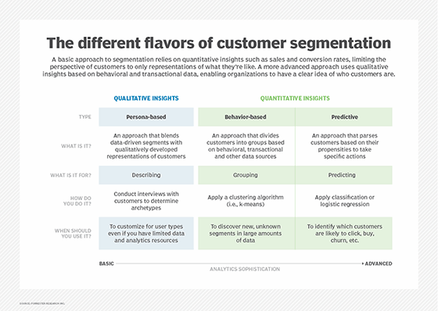

<https://searchcustomerexperience.techtarget.com/definition/customer-segmentation#:~:text=Customer%20segmentation%20is%20the%20practice,gender%2C%20interests%20and%20spending%20habits>.

At its most basic, customer segmentation (also known as market segmentation) is the division of potential customers in a given market into discrete groups.

There are three main approaches to market segmentation:

* *A priori* segmentation
* *Needs-based* segmentation
* *Value-based* segmentation

https://openviewpartners.com/blog/customer-segmentation/#.X2Ncs2gzY2w

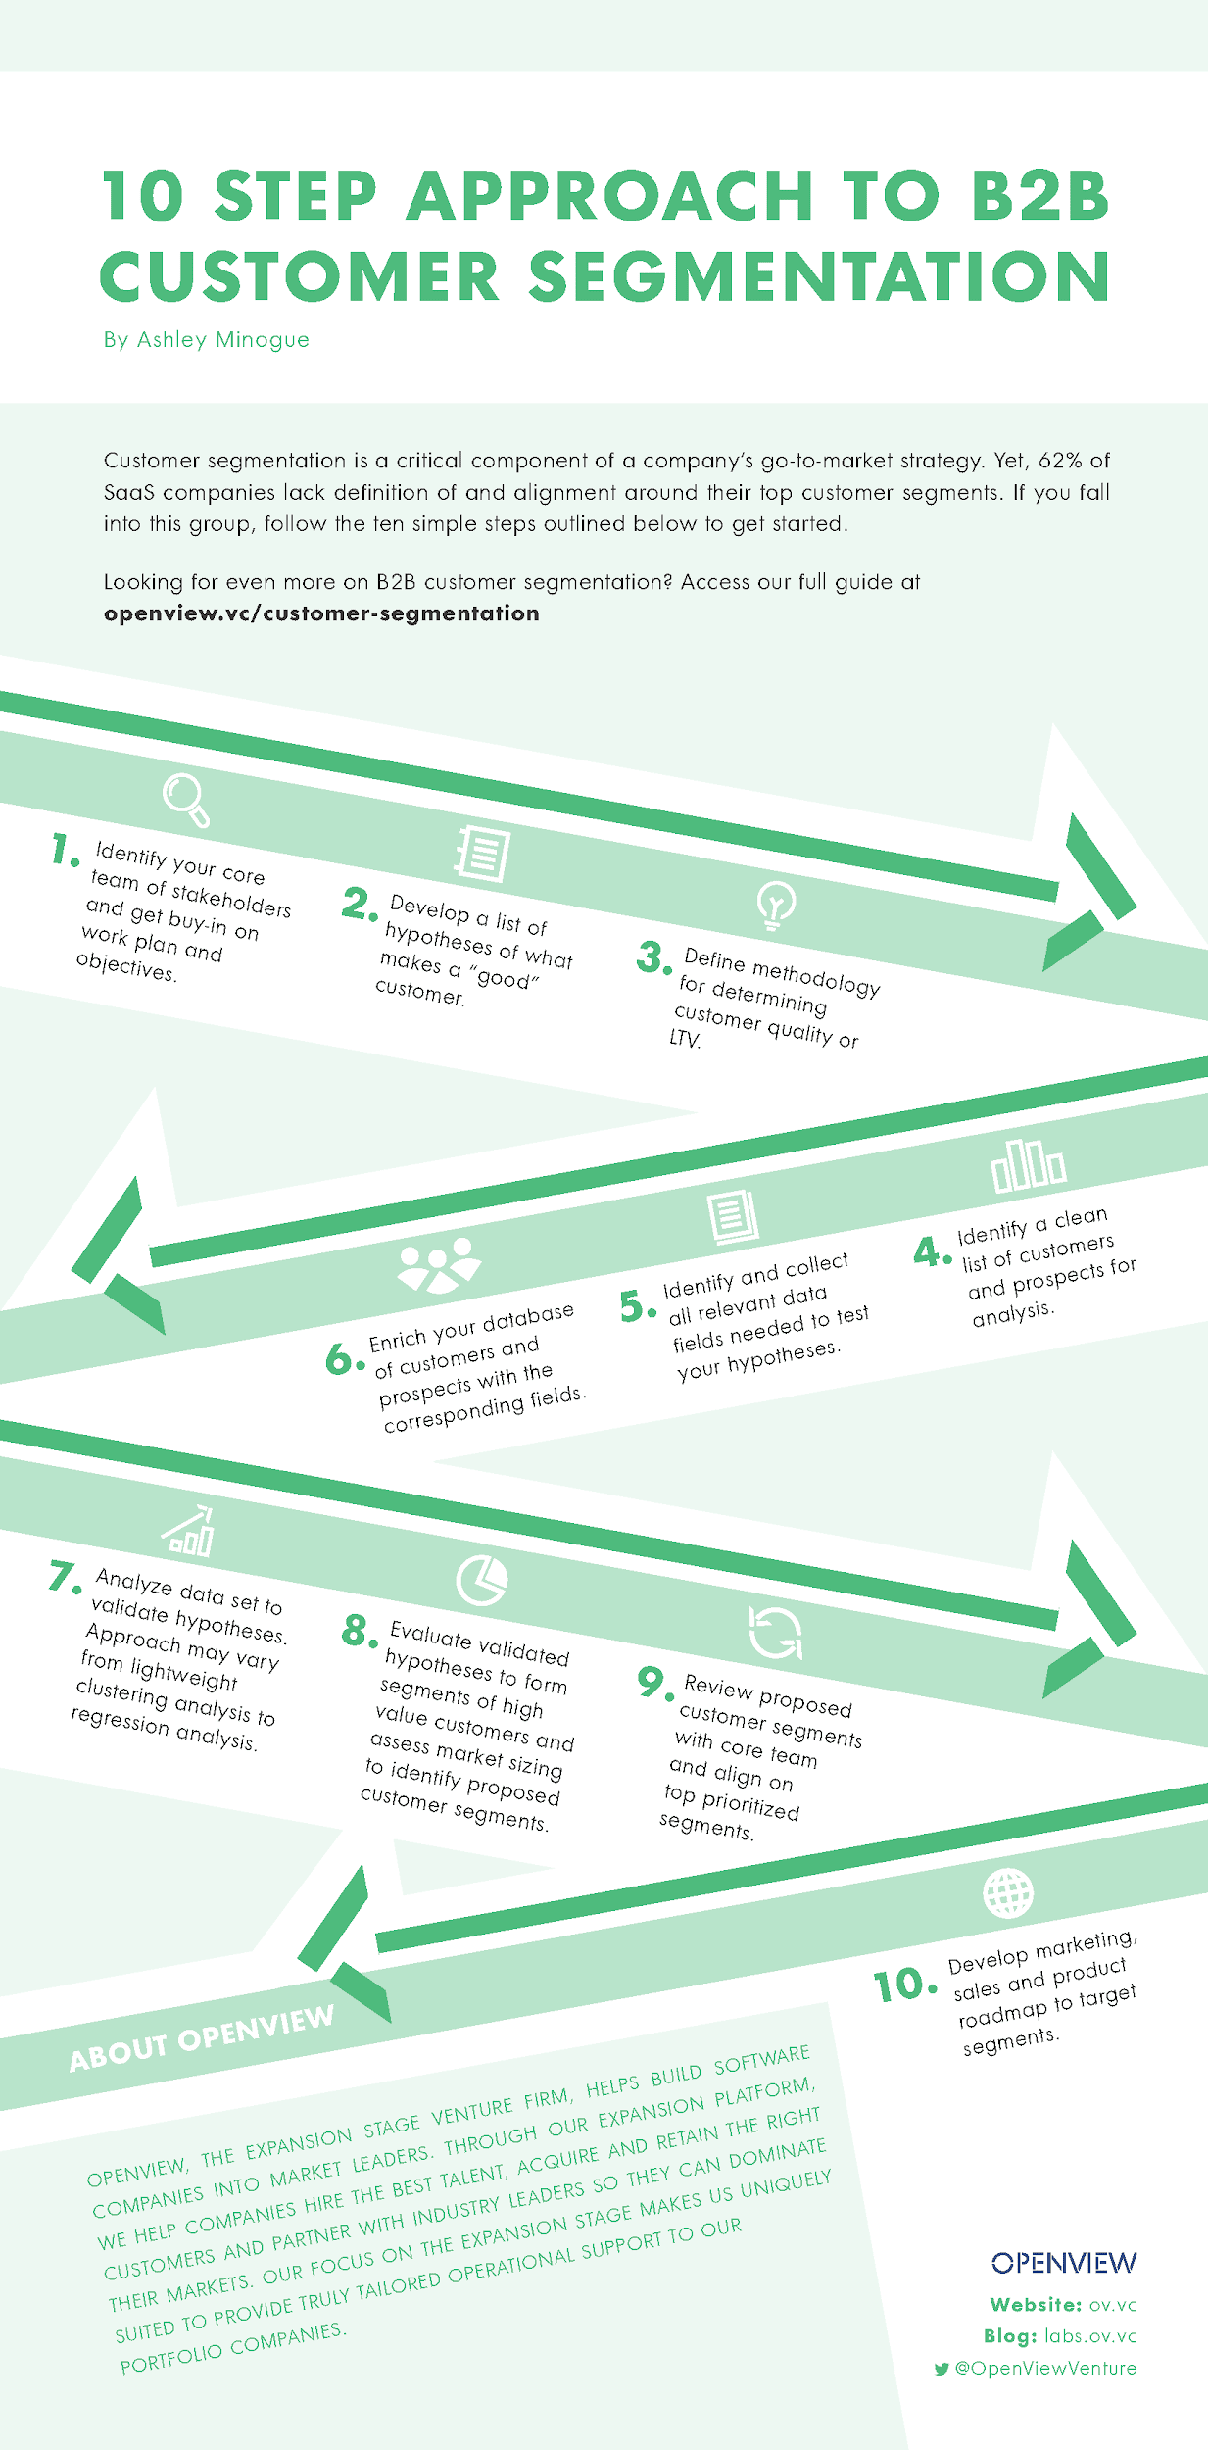

<https://openviewpartners.com/blog/10-step-approach-b2b-customer-segmentation-infographic/#.X2NmoGgzY2w>

## Why Segment Customers?

Segmentation allows marketers to better tailor their marketing efforts to various audience subsets. Those efforts can relate to both communications and product development. Specifically, segmentation helps a company:

* Create and communicate targeted marketing messages that will resonate with specific groups of customers, but not with others (who will receive messages tailored to their needs and interests, instead).
* Select the best communication channel for the segment, which might be email, social media posts, radio advertising, or another approach, depending on the segment.
* Identify ways to improve products or new product or service opportunities.
* Establish better customer relationships.
* Test pricing options.
* Focus on the most profitable customers.
* Improve customer service.
* Upsell and cross-sell other products and services.

<https://www.shopify.com/encyclopedia/customer-segmentation>

### **How banks can segment the customers in the digital world?**

1. **Demographic Segmentation**

Demographic segmentation is most common which includes information about the existing customers. It is particularly useful for identifying age, sex, marital status, family size, age of children, income, occupation, geographic location, education, race, religion and nationality.

Commercial bank customer segmentation includes type of business, number of employees, age of business, organization structure and geography

1. **Psychographics segmentation**

Banks take every effort to understand their customer through different channels and insights derived from various source like personality traits, values, attitudes, interest and lifestyle to build effective communication channel. Banks can use psychographics as the window to identify the most likely customer to experience their discomfort

<https://blog.aspiresys.com/banking-and-finance/segment-your-customers-for-the-best-banking-experiences-using-ai/>

# **RFM analysis for Customer Segmentation**

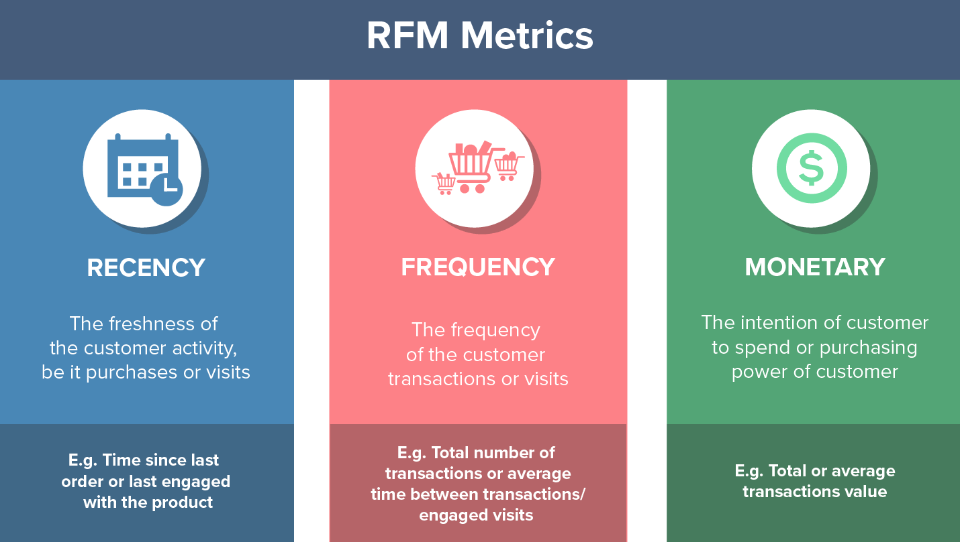

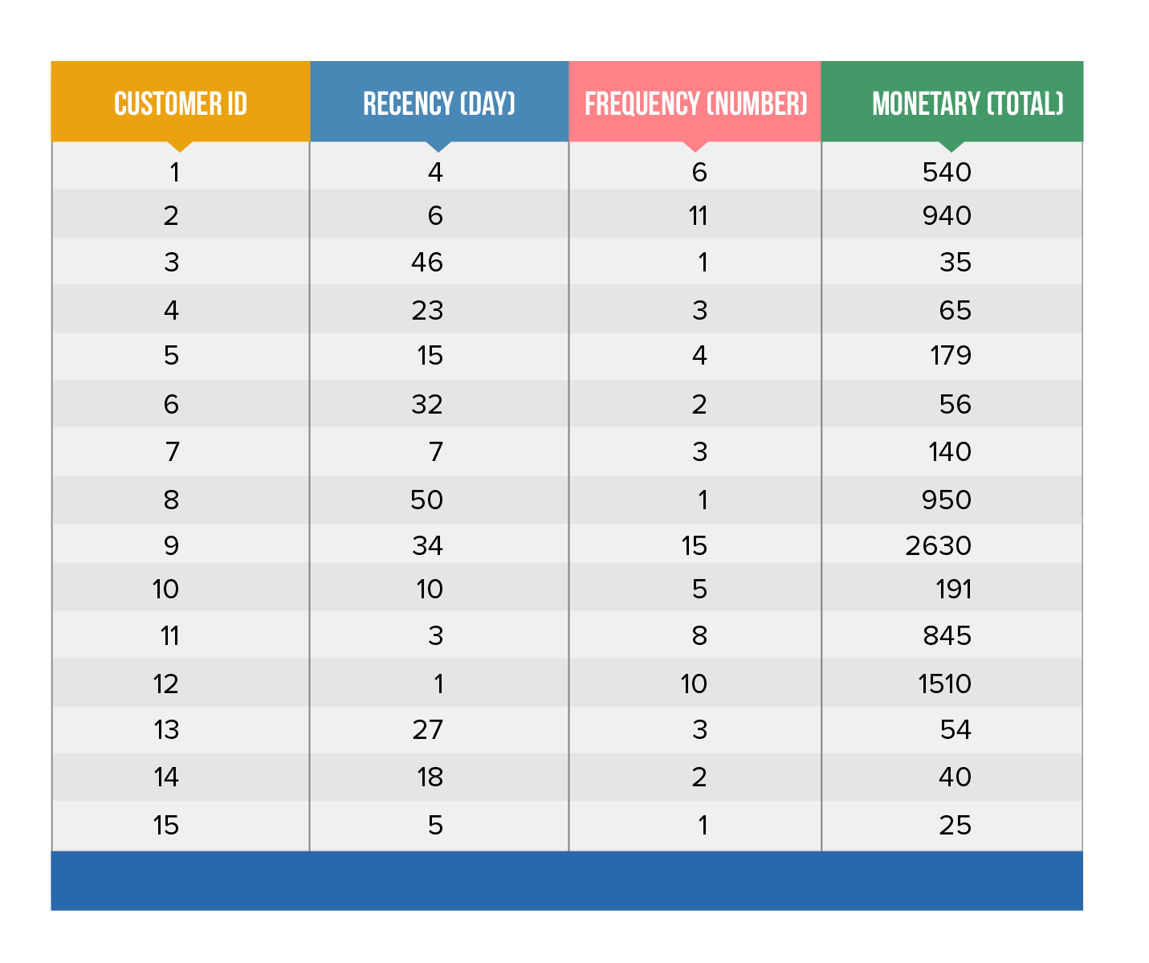

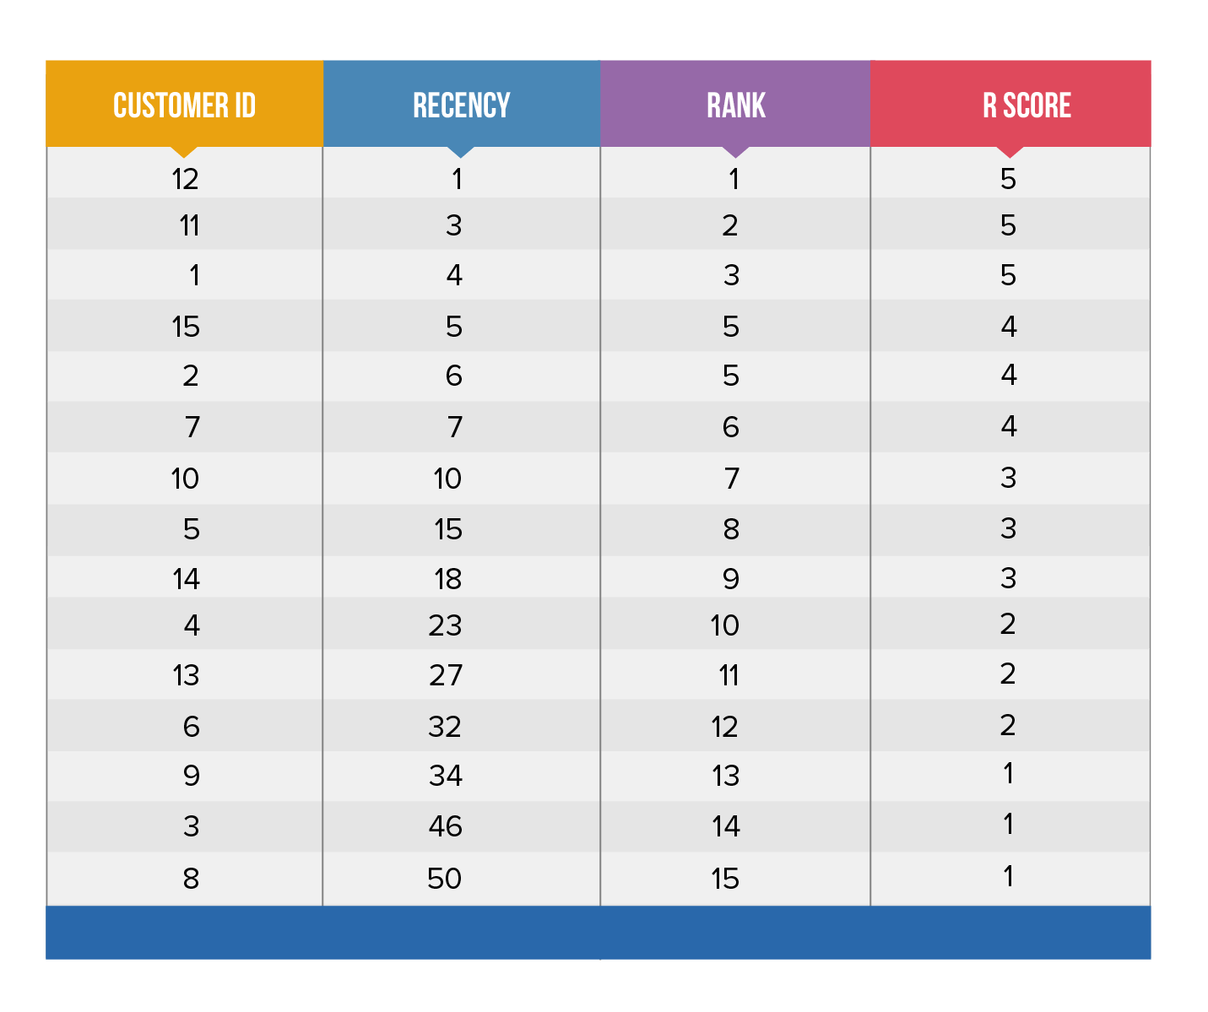

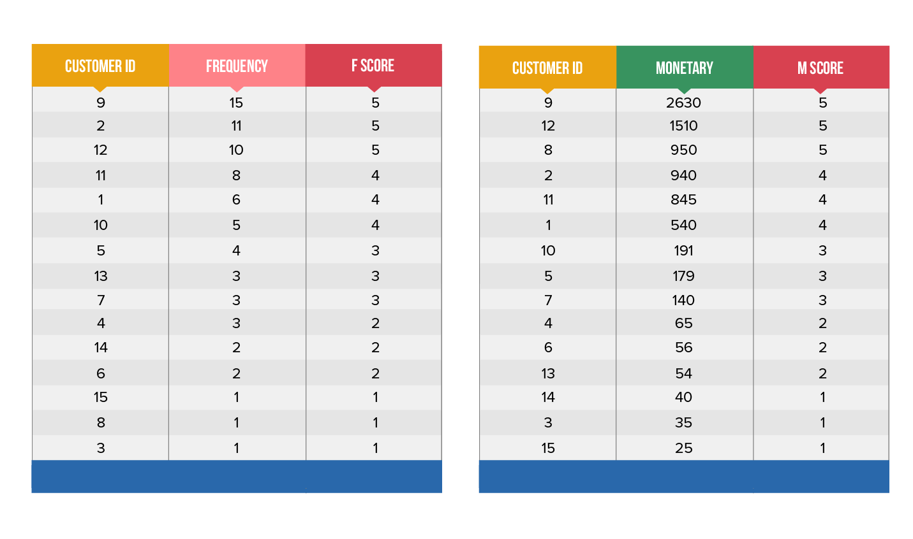

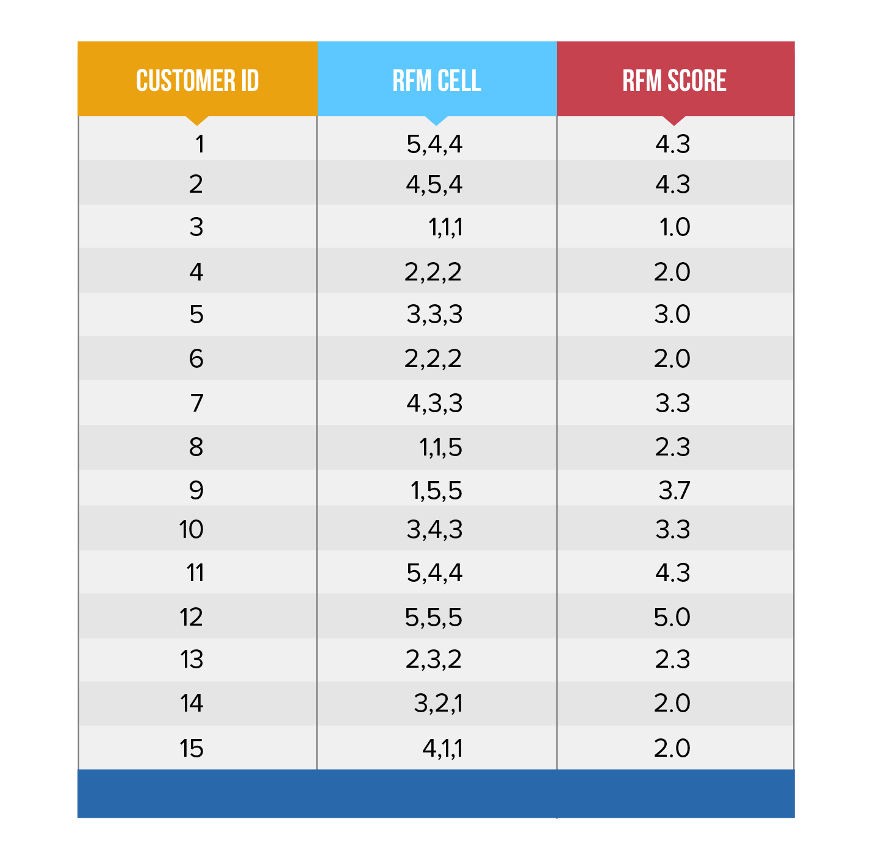

<https://clevertap.com/blog/rfm-analysis/>

data: <https://www.kaggle.com/prakharrathi25/banking-dataset-marketing-targets?select=train.csv>

code:

<https://www.kaggle.com/berkinkaplanolu/banking-analyze>

<https://www.kaggle.com/fabiendaniel/customer-segmentation/comments>

<https://www.kaggle.com/rochdi/understanding-banking-crises-in-africa>

<https://www.kaggle.com/bsivavenu/analysis-of-banking-data>

<https://www.kaggle.com/c/santander-product-recommendation/discussion/26786>

<https://www.kaggle.com/c/analytics-in-banking/data>

<https://www.kaggle.com/c/business-analytics-in-banking/data>

<https://www.kaggle.com/roshansharma/mall-customers-clustering-analysis>

<https://www.kaggle.com/kushal1996/customer-segmentation-k-means-analysis>

<https://www.kaggle.com/vjchoudhary7/kmeans-clustering-in-customer-segmentation>

<https://www.kaggle.com/rajeshjnv/mall-customer-visually-analysis-k-means>

<https://www.kaggle.com/ioannismesionis/mall-customer-segmentation-unsupervised-learning>

<https://www.kaggle.com/aishu2218/mall-customer-segmentation-with-kmeans-clustering/comments>

<https://www.kaggle.com/vpfahad/market-basket-analysis-eda/comments>

<https://www.kaggle.com/kushal1996/customer-segmentation-k-means-analysis>

<https://www.kaggle.com/paulinan/bank-customer-segmentation/comments>

<https://www.kaggle.com/general/182723>

<https://www.kaggle.com/general/148613>

<https://www.kaggle.com/general/2040>

<https://www.kaggle.com/c/mlsp-2013-birds/discussion/5373>

**Analysis of Customer Segmentation in Bank XYZ Using Data Mining Technique**

* Demographic segmentation in defining customer needs, profile, prefered transaction, etc.

<https://www.researchgate.net/profile/Arta_Sundjaja/publication/256199650_Analysis_of_Customer_Segmentation_in_Bank_XYZ_Using_Data_Mining_Technique/links/0deec522017e03a1b6000000.pdf>